- Our baseline forecast assumes that President-elect Trump won't increase tariffs on US imports from the UK. In fact, the main impact on the UK outlook from Trump's victory comes from stronger global demand stoked by looser US fiscal policy.
- We expect the new administration to take a targeted approach to tariffs and the UK will be well down the list of Trump's priorities. The US has a goods trade surplus with the UK, the UK imposes relatively low tariffs on imports from the US, and those tariffs have a minimal impact on US jobs.
- We view a 'full-blown Trump' scenario in which large, across-the-board tariff increases are imposed as unlikely. Even so, the macroeconomic impact on the UK would still be limited. Our modelling suggests that if the UK retaliated, the peak hit to UK GDP would be 0.2ppts in 2027, while prices would rise 0.3ppts above the baseline.
The results of the US elections have sparked fevered speculation over how US trade policy will impact trade flows and the outlooks for economic growth and inflation around the world. Our new baseline forecast assumes that President-elect Trump adopts a targeted approach to tariffs, and that the UK isn't subject to any change to the tariffs currently in place. As a result, the main impact on the UK outlook from Trump's victory comes from stronger global demand arising from looser US fiscal policy.
As we've noted, however, predicting Trump's behaviour is very difficult, particularly when it comes to tariffs. But even our most extreme scenario – a 'full-blown Trump presidency' in which large tariff increases are applied across-the-board – would have a relatively small impact on UK GDP growth and inflation (Chart 1).
Chart 1: Even the most extreme Trump scenario would have a limited impact on UK GDP and prices
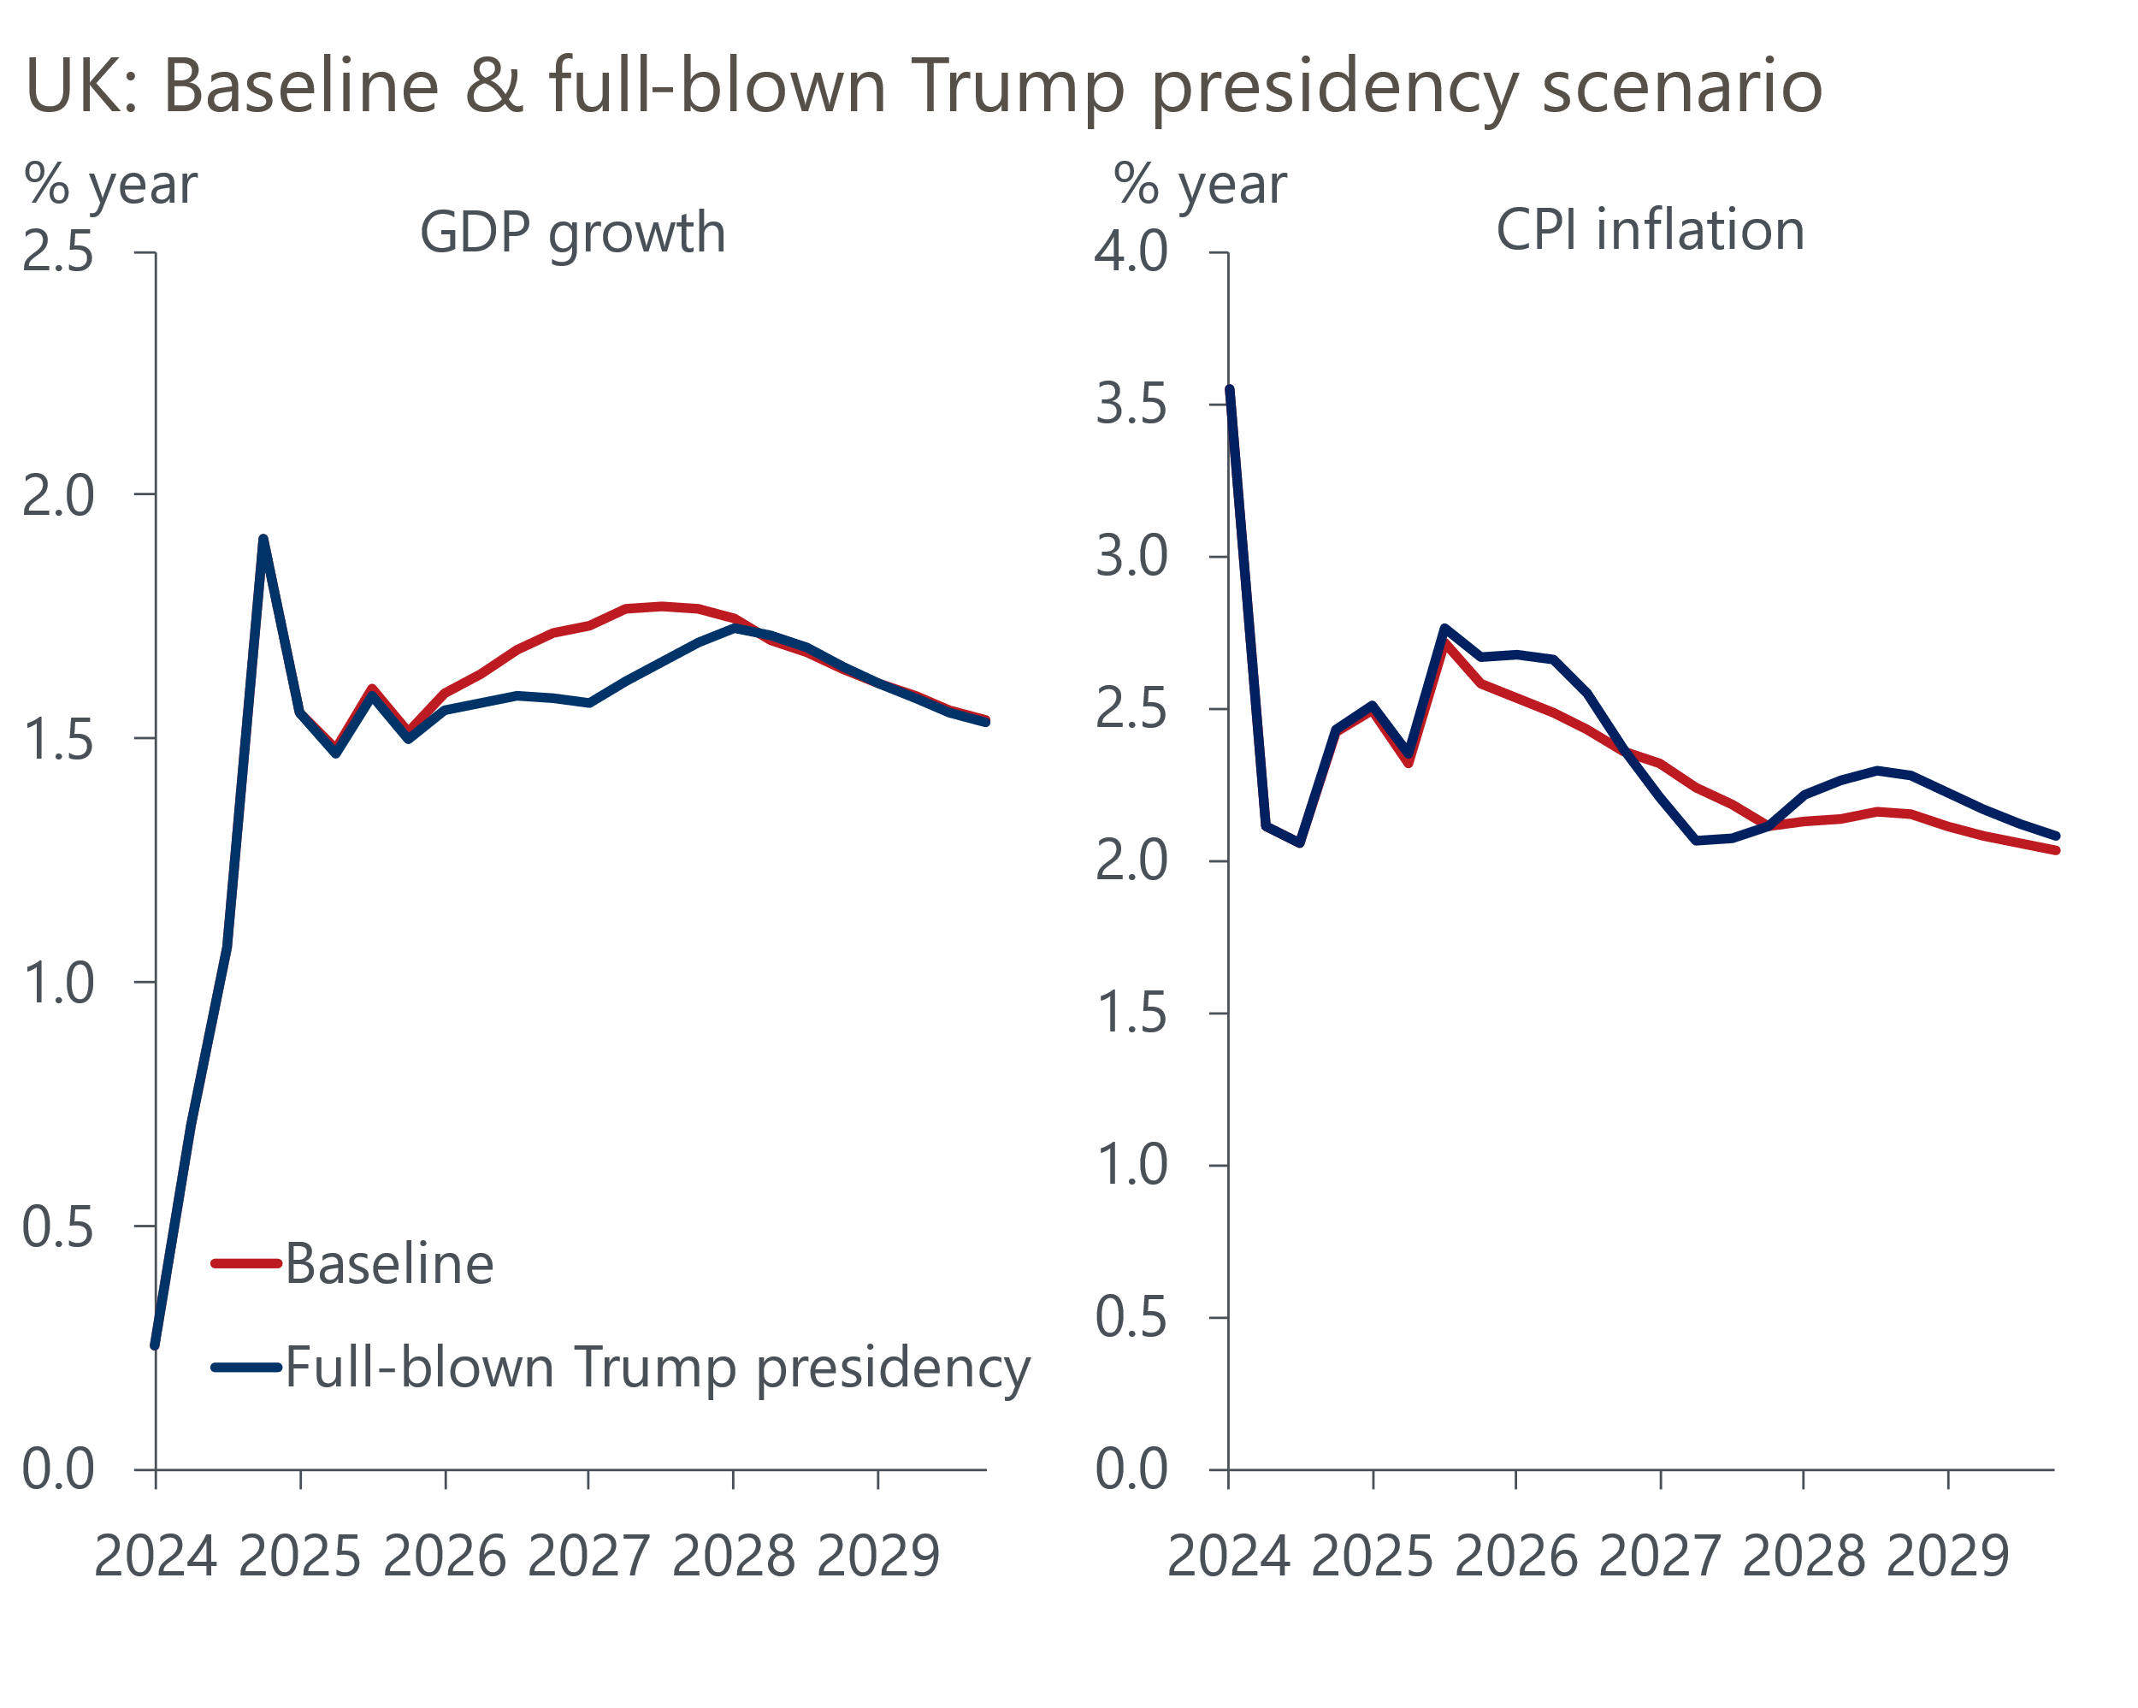
Sources: Oxford Economics, Haver Analytics

We examined the mechanics of tariffs in a recent Research Briefing. Trade tariffs are a tax levied on imports. In most cases, they are of the 'ad valorem' type whereby importers in a country are obliged to pay a certain percentage of the value of imports from foreign countries as a tax. So a 10% tariff raises the price of an import by 10%.
Tariffs affect the economy by making imports more expensive relative to domestic goods. If the tariff is only levied against one country or a small number of countries, imports from those countries also become more expensive relative to imports from countries not affected by tariffs.
As a result, tariffs can have a number of effects:
- They tend to divert spending in a country to domestic production and to imports from countries not affected by the tariff.
- They tend to raise prices in the country that imposes the tariff.
- They can impact on economic growth in the tariff-raising country both positively and negatively. The tariff-raising country may gain from higher domestic production due to expenditure switching and increased government revenue, but higher prices in the tariff-raising country may also hurt consumer spending and investment by reducing real incomes.
Growth in the countries hit by tariffs will tend to be lower as their exports are reduced. Growth in any countries not hit by tariffs might rise if they benefit from increased exports to the tariff-raising country.
There is no free-trade agreement between the US and UK, so both countries levy their most-favoured nation (MFN) tariffs on imports from the other. The WTO reports that in 2023, the trade-weighted average duty on UK imports was 3.3%, and on US imports it was 2.2%.

Trump is unlikely to view the UK as a priority for increasing tariffs
Trump's rhetoric in the election campaign centred on large increases in tariffs on imports from China, though he also floated the idea of across-the-board tariffs on all other US trading partners. We think legal obstacles make across-the-board tariffs unlikely, and we expect the US to pursue a targeted approach.
Trump's campaign identified several criteria to determine which trading partners might be subject to higher tariffs. A key indicator is the trade balance, with Trump viewing large US trade deficits as problematic. But the US had a goods trade surplus of $10.5bn with the UK in 2023 (Chart 2).
Chart 2: The US enjoys a goods trade surplus with the UK
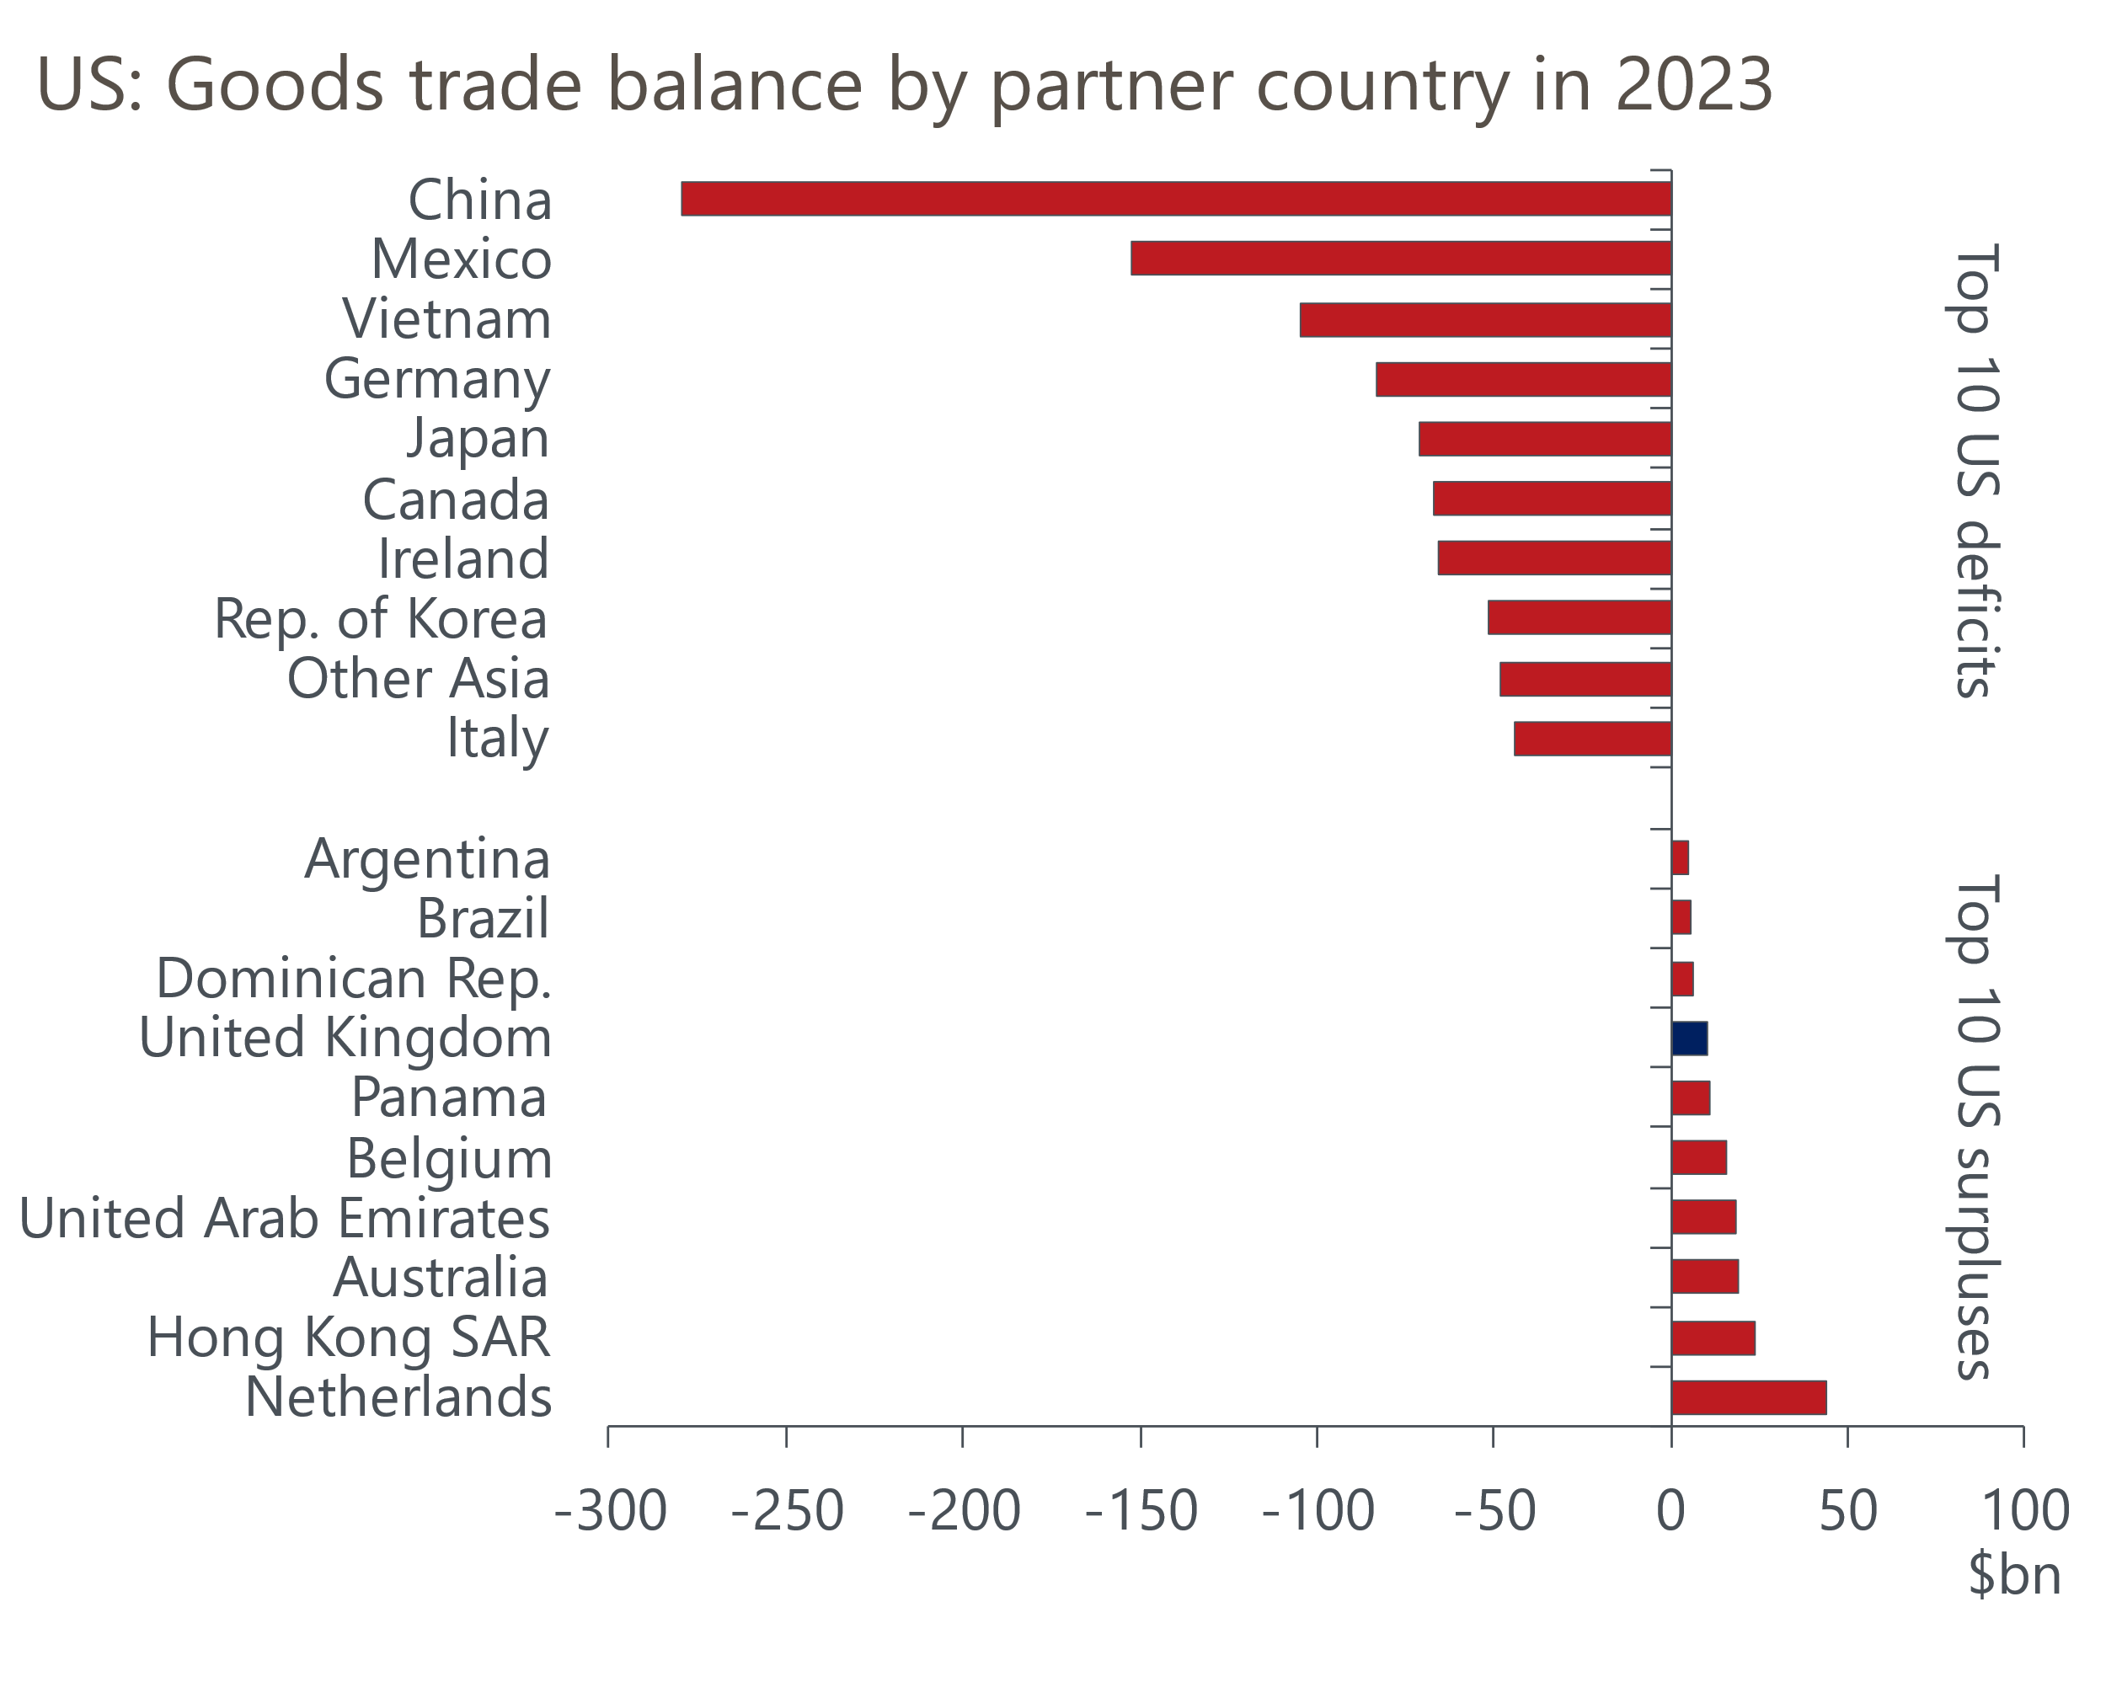
Source: Oxford Economics calculations using data from UN Comtrade database
Other key criteria are the level of tariffs imposed on imports from the US and the impact that those tariffs have on US jobs. But UK tariffs are relatively low, and are not in sectors where there would be a material impact on US employment. In addition, the UK accounts for just 2.1% of US goods imports. So we think the UK is likely to be well down the list of priorities for the new US administration.
We will adjust our baseline forecast next week to incorporate the impact of a 30% tariff on US imports from China, along with smaller increases in tariffs on imports of specific goods from the European Union, Mexico, Canada, Japan, South Korea, and Vietnam. As we previously noted, it could take 11 months to complete the legal process to raise tariffs, which means the adverse effects of tariff hikes might not be felt until 2026. We will assume that tariffs on US imports from the UK remain unchanged.
Compared with our October baseline, which had assumed a continuation of the political status quo in the US, the impact of imposing these new trade assumptions on the UK forecast is minimal. The growth impact of US trade policy is more than offset by the boost to global demand from looser US fiscal policy.

A 'full-blown Trump' scenario would have a limited macroeconomic impact on the UK
We will also model a range of alternative scenarios with tariff increases of varying scale and breadth. This will include scenarios in which higher tariffs are levied on US imports from the UK. We will publish the results of our modelling of these scenarios and the implications for the UK economy soon.
In scenarios where higher tariffs are imposed, the sectoral impact will be uneven. Medicinal and pharmaceutical products stands out as a relatively large sector that is heavily reliant on trade with the US (Chart 3). Mechanical power generators and cars are the other two sectors that account for more than 5% of UK exports and are more heavily exposed to the US market than the average.
Chart 3: The sectoral impact of higher tariffs would be uneven; pharma is particularly vulnerable
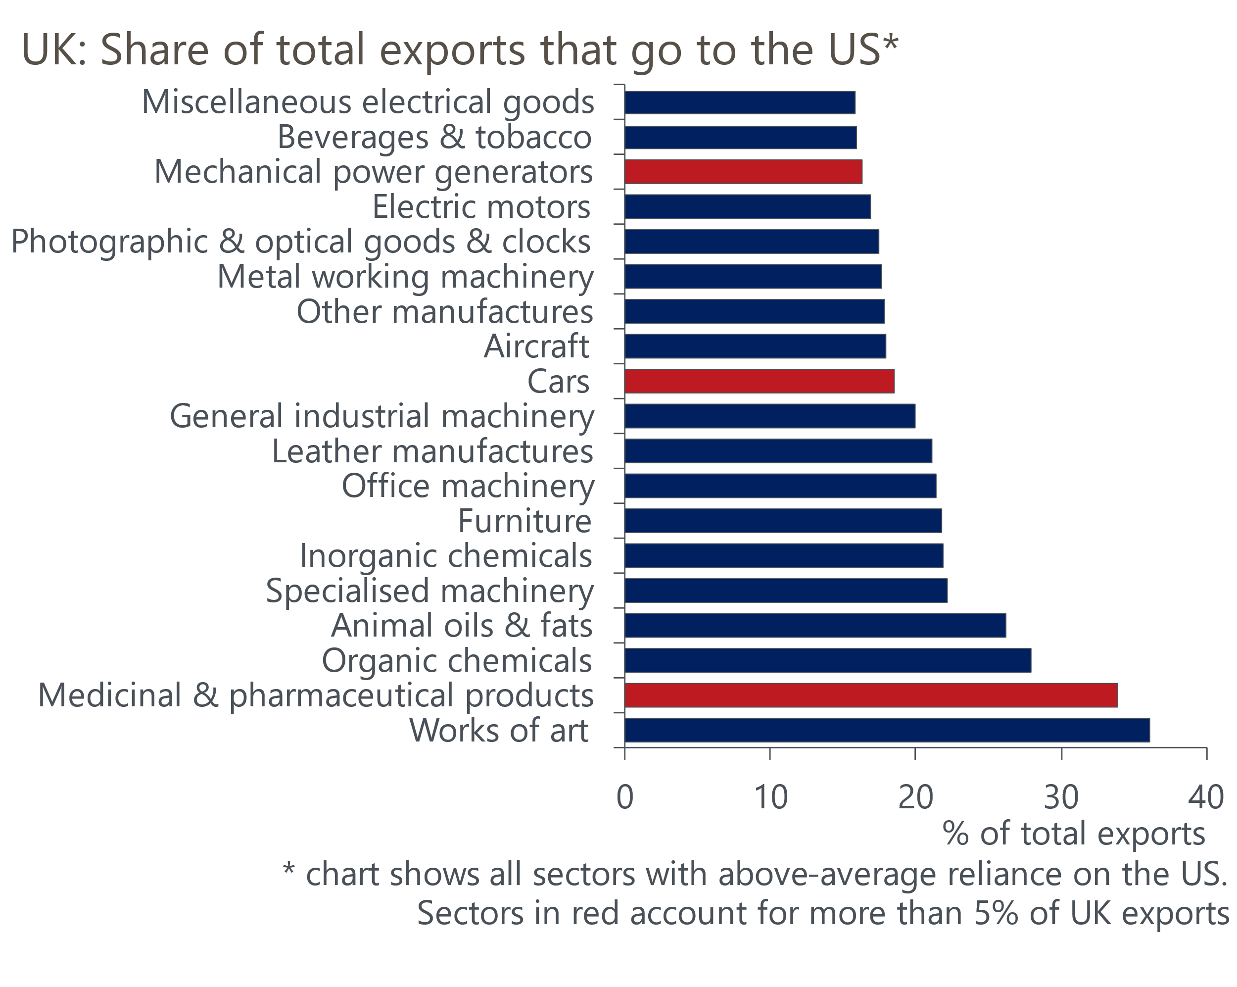
Source: Oxford Economics calculations using data from ONS
But while the impact of higher tariffs will be significant for some sectors, the macroeconomic impact will be much more limited. Given the uncertainty around the policy direction a Trump administration might take, we've updated our 'full-blown Trump presidency' scenario continuously in recent months. This scenario is a good benchmark for what could plausibly happen if Trump follows through on the threats made during the campaign.
Our baseline forecast assumes the average US tariff rises by around 2ppts from current levels to 5% by 2028. The full-blown scenario assumes across-the-board tariffs of 10% on all goods imported into the US and 60% tariffs on imports from China, taking the average US tariff back to the level seen in the 1930s. It also assumes US fiscal policy is more aggressive than in the baseline forecast and curbs on immigration are higher. As with the baseline, we assume that it takes time for higher tariffs to be implemented. We also assume full retaliation by other countries, including the UK.
In this scenario, US inflation rises due to the tariff increases and more expansionary fiscal policy. The Federal Reserve responds aggressively, pausing interest rate cuts in 2026 and then nudging rates higher in 2027 to prevent inflation expectations from becoming unanchored. This helps to contain the acceleration in consumer prices. However, it also means that after an initial boost from looser fiscal policy, US GDP falls below the baseline.
Given this scenario assumes full retaliation, the imposition of tariffs on goods imports from the US raises UK inflation. The impact is compounded by sterling remaining weaker against the dollar than in the baseline forecast, reflecting tighter US monetary policy. But there's some offset from weaker activity, as global GDP falls below the baseline. This limits the peak impact on UK consumer prices to 0.3ppts.
On the growth side, exports are weaker due to both the reduction in trade with the US prompted by the tariff increase and softer global growth. Consumer spending and investment are also slightly lower than in the baseline, reflecting the impacts of higher inflation and weaker confidence. But the impact on GDP would be mitigated by lower imports. So the peak drag on UK GDP is limited to 0.2ppts.

UK impact could be lower if there's no retaliation
The impacts on UK growth and inflation in this scenario are much smaller than those published by other organisations over the past week. In part, this is likely to reflect the assumption of looser US fiscal policy in our scenario. But even controlling for that difference, other estimates look excessive in our view.
A worked example shows that the direct impact on inflation from the UK imposing retaliatory tariffs on goods would be small. Even assuming full pass-through of the tariff increase, the maximum impact on inflation from tariffs would be 0.19ppts based on the tariff rise (6.2%) x US's share of UK goods imports (10%) x the goods import share in the UK CPI basket (30%). Studies that show much larger impacts imply very large indirect effects, perhaps though damage to productivity or large negative impacts on financial markets. But we think the indirect impacts are likely to be small.
In our scenario, the tariff increase is responsible for a large part of the increase in UK inflation. So a scenario where the UK decides not to retaliate would have an even lower impact. We think it's far from given that the UK would retaliate in this situation. The UK has a much heavier reliance on goods imported from the US than the other way around, suggesting that retaliation would be self-defeating.

